**Aim**: - CI/CD Pipeline Project, Maven Job, Schedule project and source code polling in Jenkins.

To add Maven Plugin in Jenkins site:

Dashboard>Manage Jenkins>Manage Plugins>Available plugins: Maven integration and green ball>Install without restart.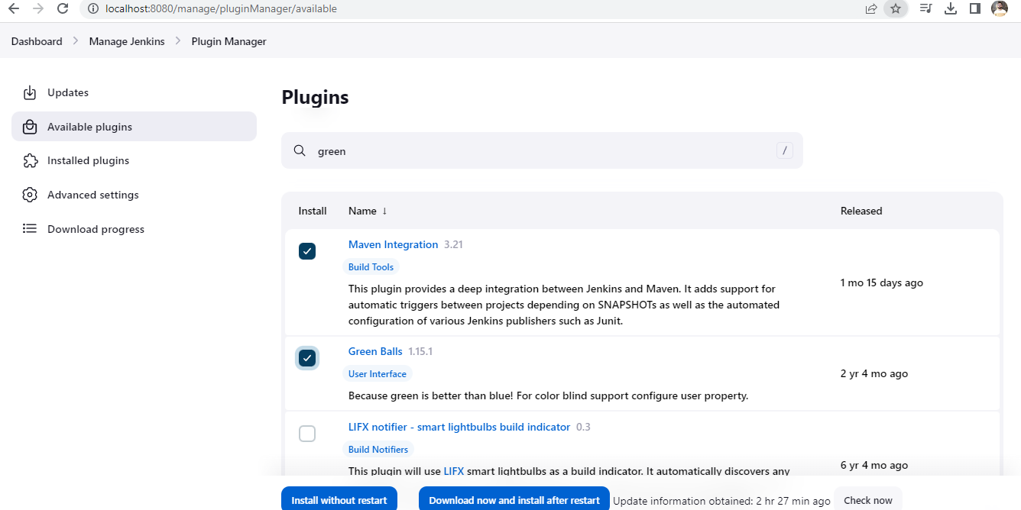

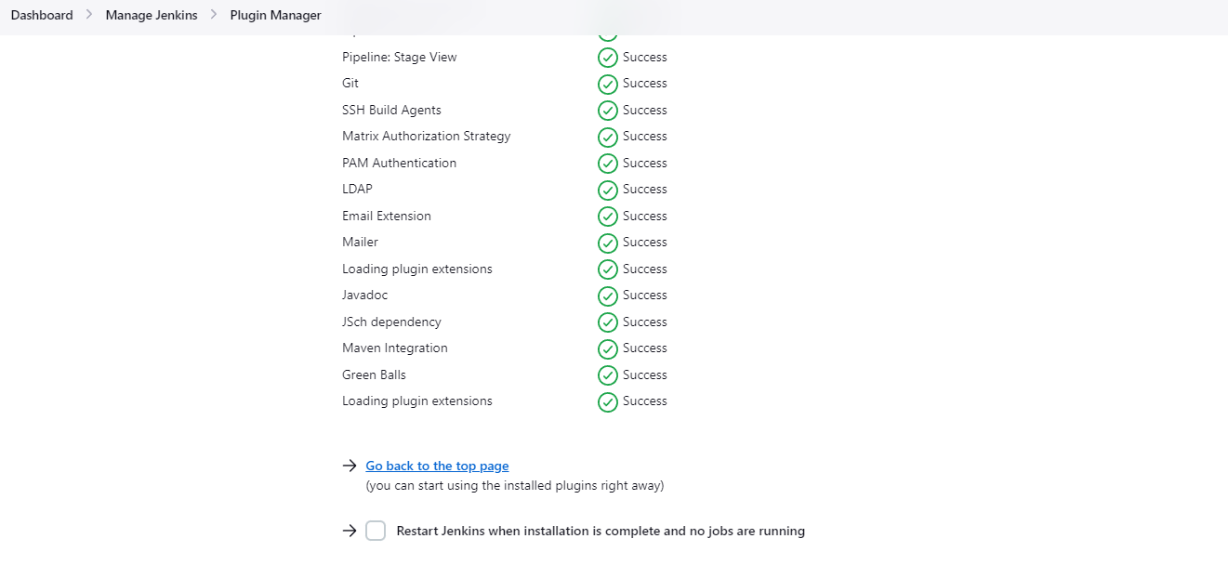

To check the maven plugins:

Dashborad>+ new item>Showing the Maven project option

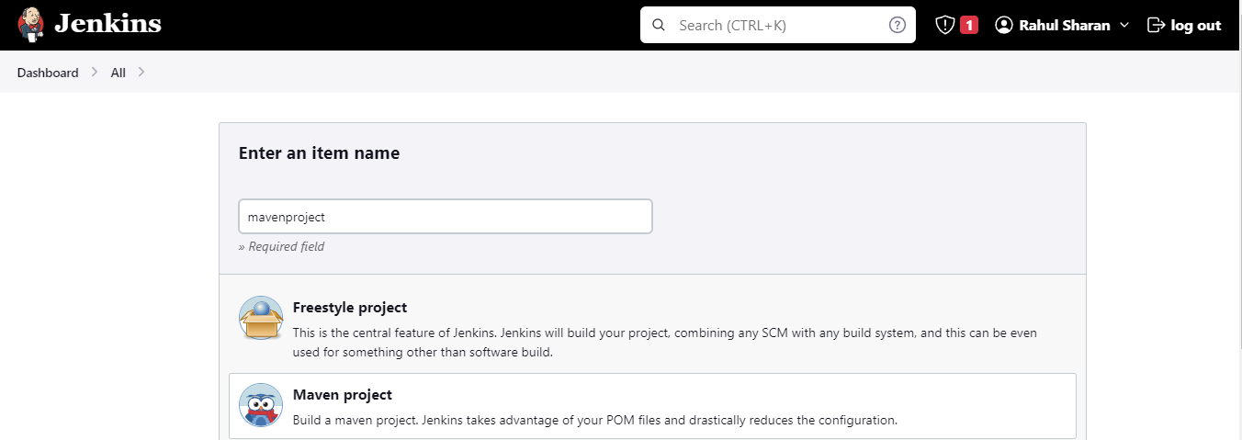

To configure the global tools like: git java and maven:

Dashboard>Manage Jenkins>Global tool configuration

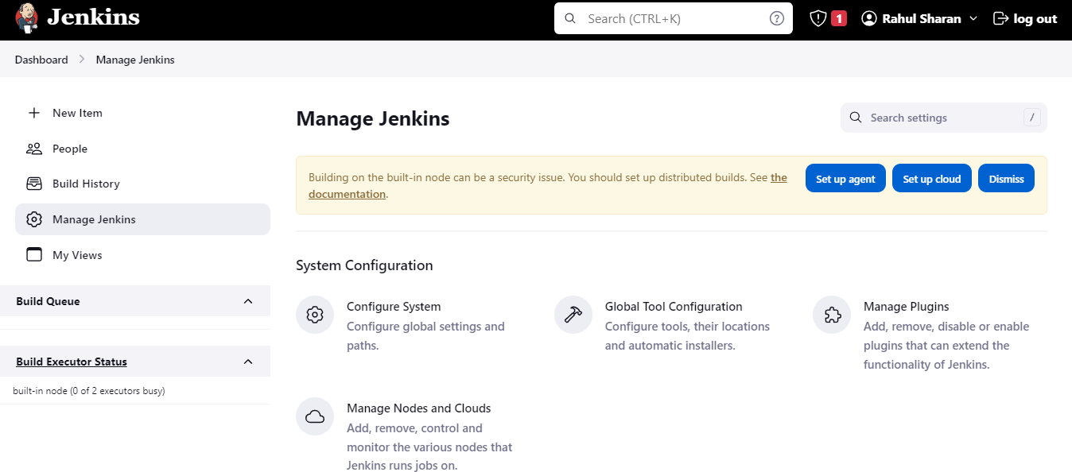

GIT configuration: Selected default

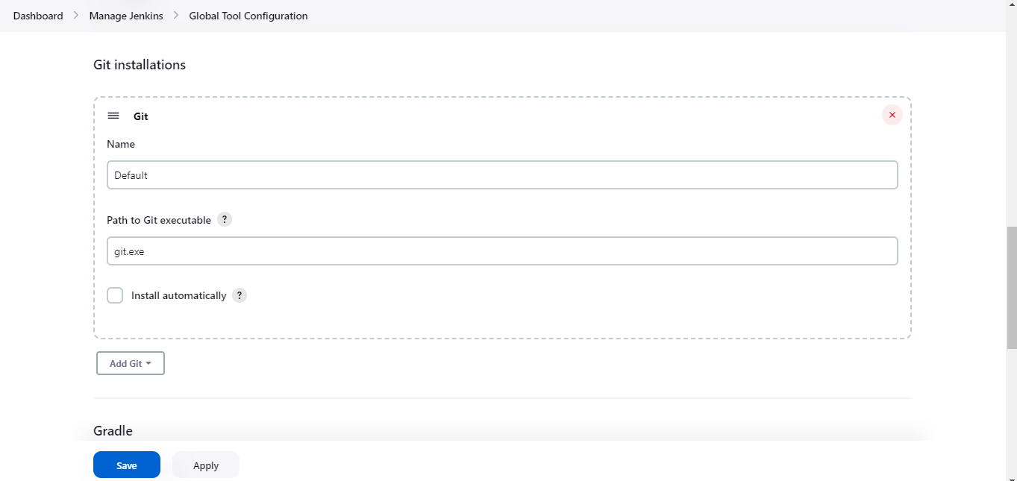

Java path configuration:

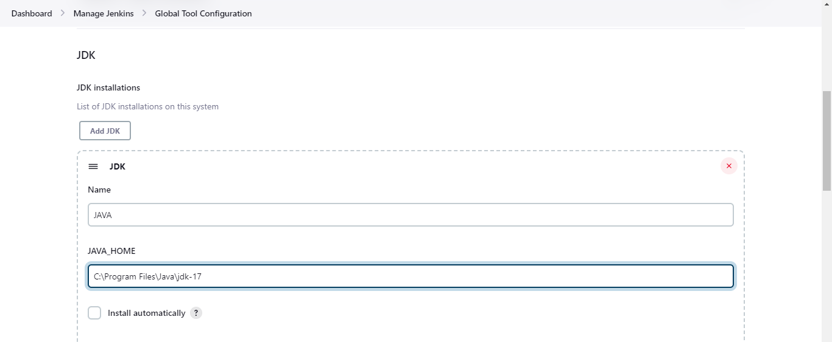

Maven path configuration:

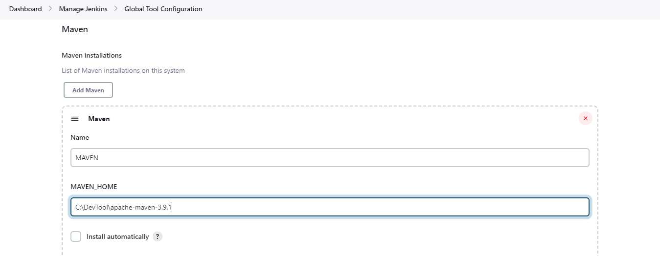

To create a Maven project: time tracker project by using CMD

Copy the code from GitHub:

<https://github.com/technicalguftgu/time-tracker.git>

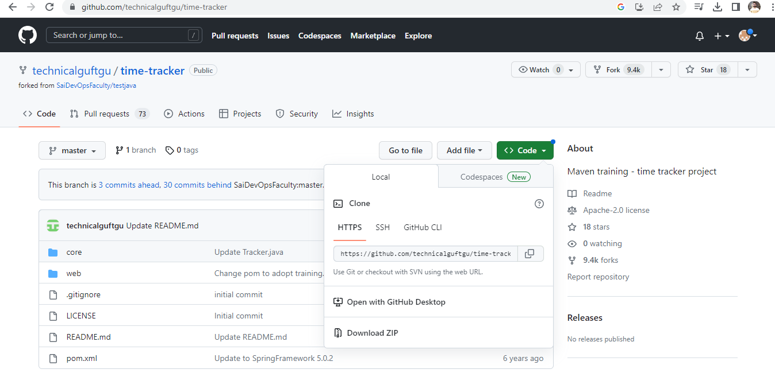

Open the command prompt cmd on windows:

Go to home directory using following command:

>cd ../..

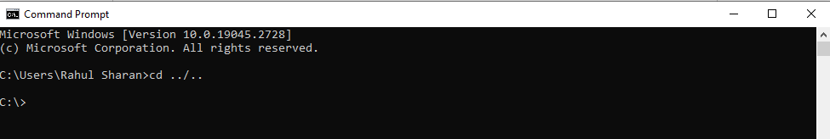

To git clone into time tracker by using the GitHub code:

>git clone <https://github.com/technicalguftgu/time-tracker.git>

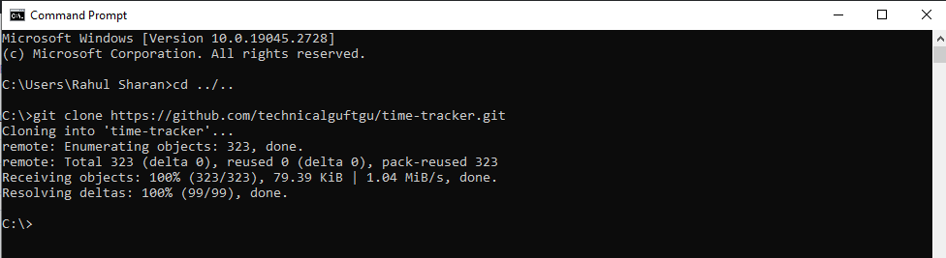

To check the time tracker code using following command:

>dir

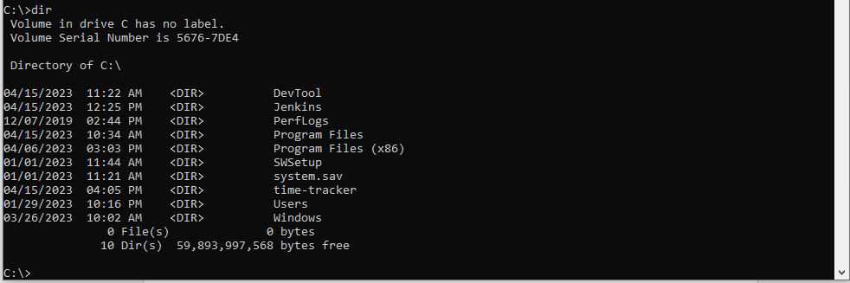

To check the time tracker by using GUI:

C:\time-tracker

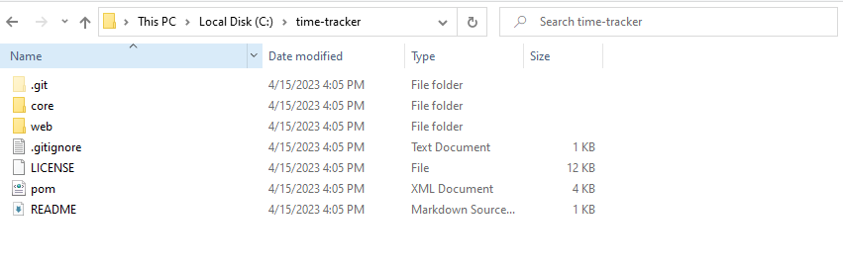

To change the directory by using the following command:

>cd time-tracker



To build the code, Code convert into machine language by using the following command:

>mvn clean package

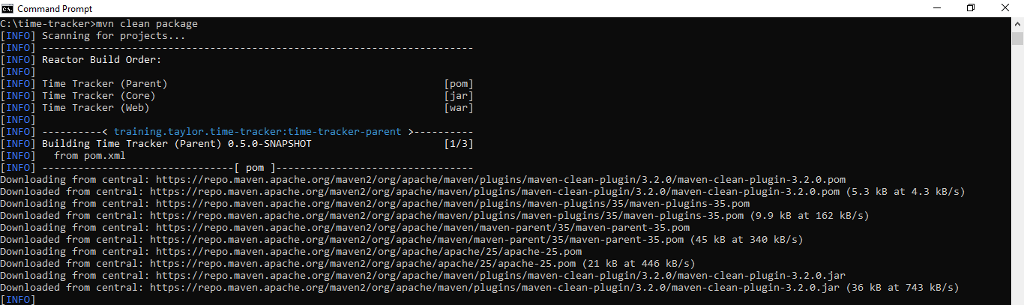

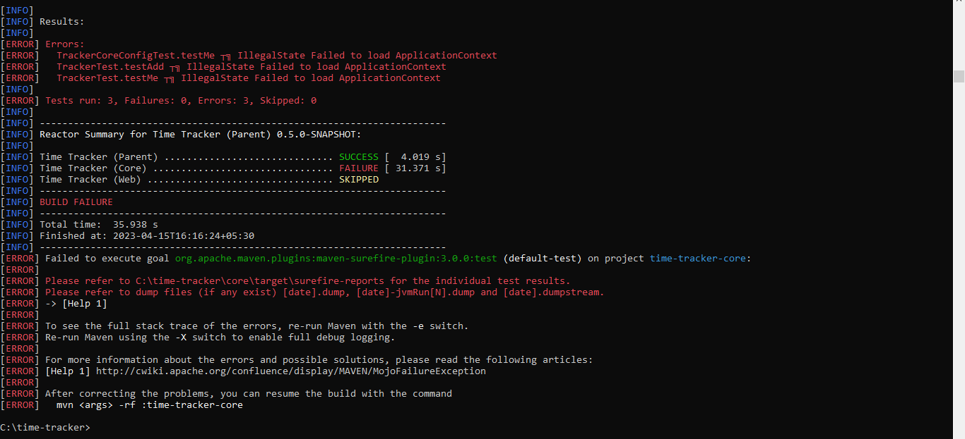

To create a Maven project: time tracker project by using Jenkins:

Go to Jenkins>+new items: name: MyMavenProject>MavenProject>Ok

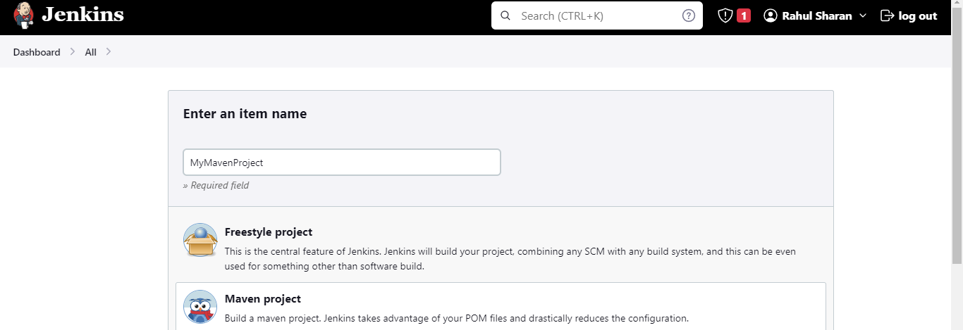

Source code management: Git

URL: https://github.com/technicalguftgu/time-tracker.git

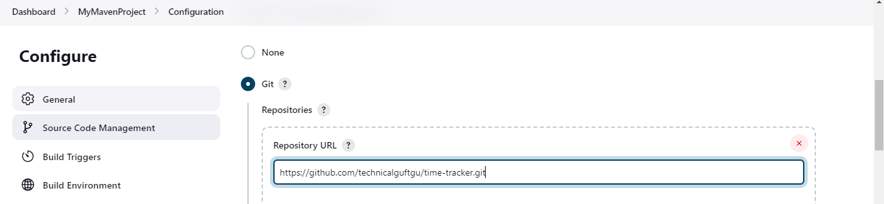

Build Configuration

Goal and options: clear package >apply and save

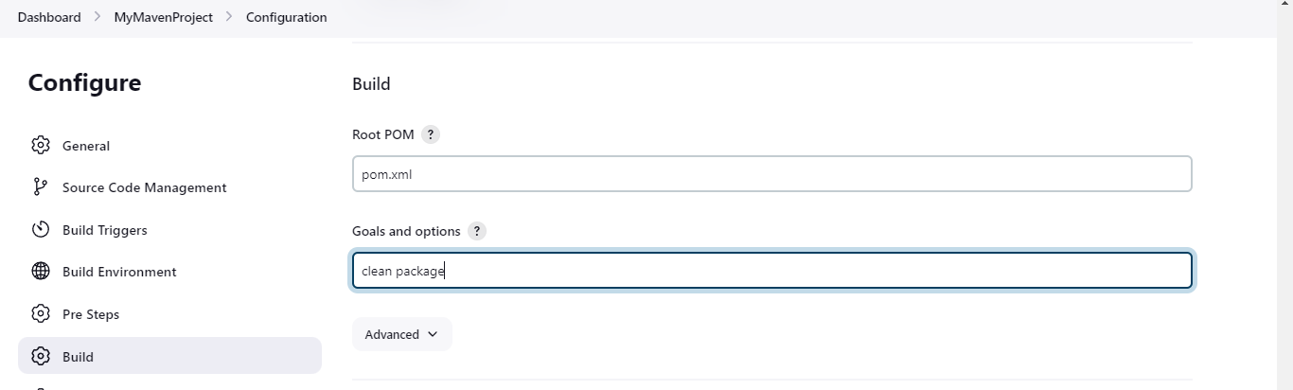

Go to dashboard and right click on MyMavenProject and click on build now:

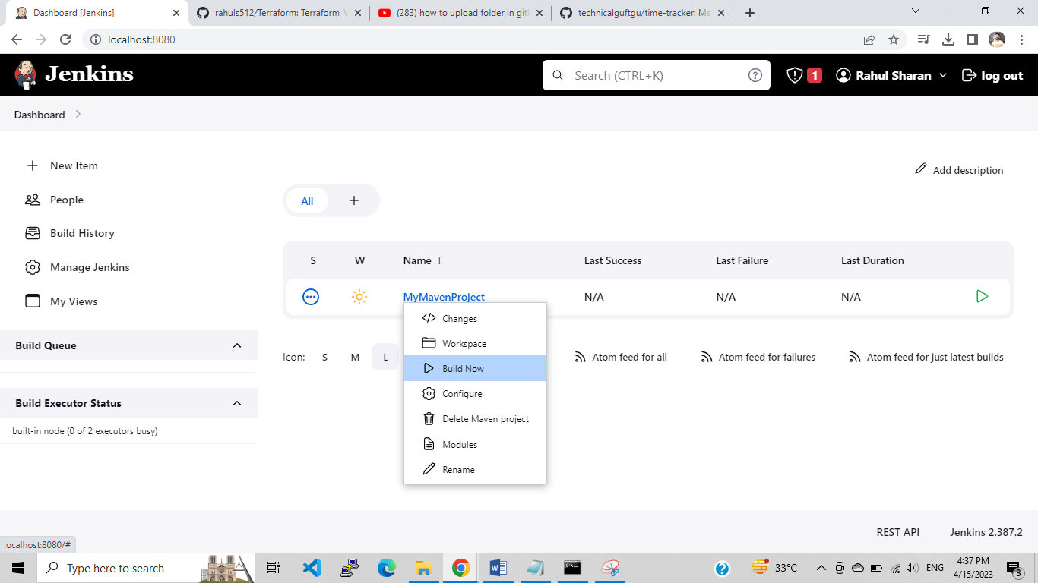

Schedule project and source code polling (SCM) in Jenkins:

Schedule project using Build periodically:

Jenkins>Dashboard>Right click on myfirstproject>Configure> Build Triggers: Build periodically

Schedule: * * * * *

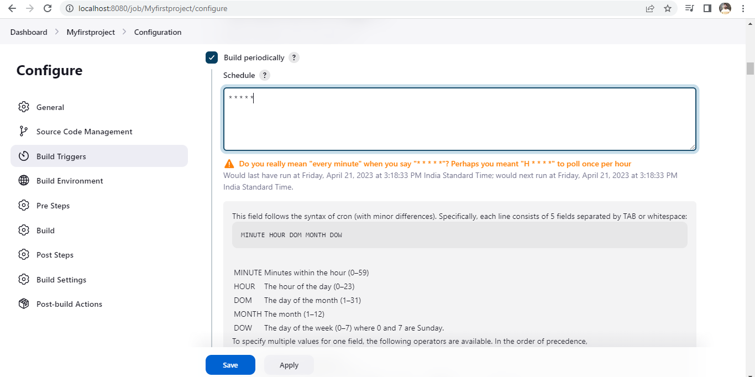

Check the status of project build after 1mint:

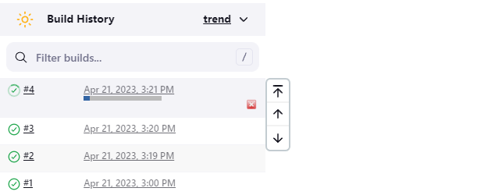

Schedule project using the source code polling (SCM):

Jenkins>Dashboard>Right click on myfirstproject>Configure> Poll SCM:

Schedule: * * * * *

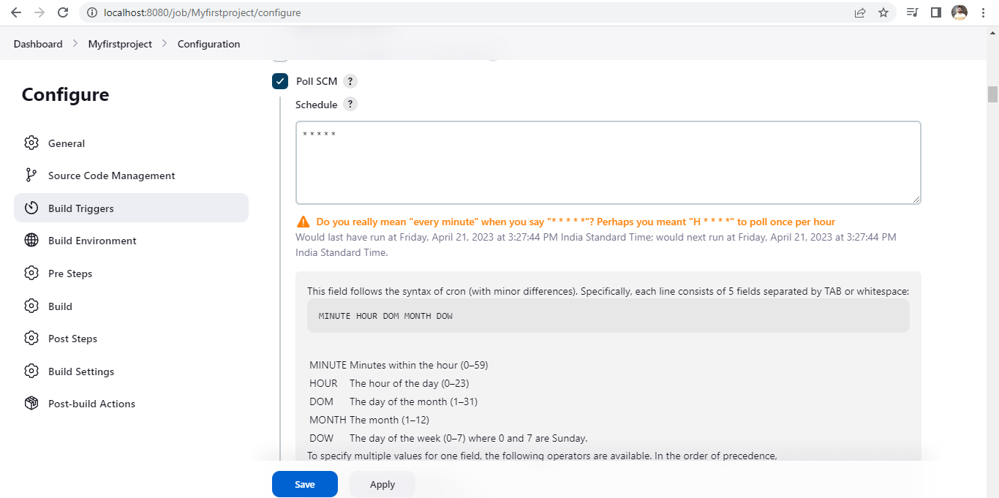

Go to source code and edit the code:

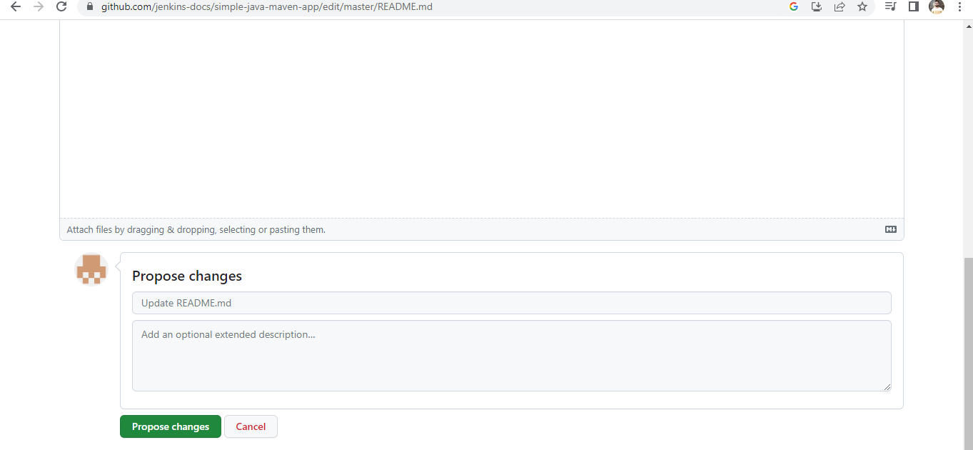

After change edit code, check the status of project build:

